Drinking Water Safety Planning for a Planned Event Temporary Drinking Water Supply

Name of Supplier:
Name of Event:
Address of Location:
Dates of Event(s):
Dates water supplied:
Emergency Contact Name:
Emergency Mobile No:

Revision history

Revision | Comment | Date | Initials

Contents
Introduction 3
1. Drinking water safety planning team 4
2. Leadership and Capability 5
2.1 Leadership 5
2.2 Operator Capability 5
3. Flow diagram or schematic 7
4. Understanding your water supply 8
4.1 Can you provide sufficient drinking water? 8
4.2 Do you understand your source water? 9
4.2.1 Using drinking water a registered drinking water supplier 9
4.2.2 Using untreated or mixed source water 10
4.2.3 How will you give effect to the principles of Te Mana o te Wai as they apply to your temporary drinking water supply? 11
4.3 What treatment processes do you have? 12
4.4 How will you store and distribute your water? 13
4.5 What does your supply look like? (Photographs of site, source, key plant, and equipment) 15
5. Hazard identification and controls 16
5.1 Qualitative descriptors of the likelihood of an event 16
5.2 Qualitative descriptors of consequences should an event occur 16
5.3 Qualitative risk analysis matrix: Level of risk 17
5.4 Critical Control Points 17
5.5 Risk assessment table 18
6. Monitoring, verification and record keeping 19
6.1 Is your water supply system operating as expected? 19
6.2 How do you know your processes are effective? 20
6.3 What records will you keep on your temporary drinking water supply? 21
7. Incident response 22
7.1 What else could go wrong? 22
7.2 How will you respond to an incident? 22
Appendix 1 Example flow diagrams 23
Appendix 2: Log reduction requirements for protozoa 25
Appendix 3: Minimum analysis requirements for source water 26
Appendix 4: Critical Control Point Features and Decision Tree 27
Appendix 5: Example Critical Control Point Summary Sheet 28
Appendix 6: Blank Critical Control Point Summary Sheet 29

Introduction
The Water Services Act 2021 recognises that event organisers may intend to supply drinking water to people attending their events. Event organisers must either arrange for drinking water to be supplied from a registered drinking water supply, or alternatively apply to Taumata Arowai for registration of a temporary drinking water supply. The application must be accompanied by a temporary drinking water safety plan and the appropriate fee. Event organisers must supply drinking water in accordance with their temporary drinking water safety plan and any conditions set by Taumata Arowai.

This document is the approved form for a temporary drinking water safety plan. It is designed to assist event organisers to identify and manage the risks which may affect the safety, compliance (i.e., with drinking water standards) or sufficiency of their temporary drinking water supply.

It is important that your temporary drinking water safety planning is robust. Failure to adequately address the risks to your supply within your temporary drinking water safety plan is likely to result in additional conditions being applied and may delay processing of your application.

Taumata Arowai may register a temporary drinking water supply if it considers that safe, compliant drinking water can be provided. Registration may be subject to conditions that Taumata Arowai considers necessary.

Applications should be made a reasonable period of time before the start of an event to give Taumata Arowai time to complete its assessment (ideally no later than 20 working days before the start of the intended event). The event organiser will not be able to supply drinking water if Taumata Arowai does not have sufficient time to assess the application and to register the temporary drinking water supply.

Supporting documentation should be provided with your completed temporary drinking water safety plan (if necessary).

1. Drinking water safety planning team

This plan should be developed with a team of people who have a range of relevant skills and knowledge to help ensure that the planning is robust.
List the team involved in the preparation of this plan.
Record why team members have been selected to participate.
Clearly record the responsibilities or contribution of each member of the team.

Drinking water safety team members
Name | Role | Responsibilities/contribution | Skills/knowledge/experience

2. Leadership and Capability

2.1 Leadership
Provide details of the key roles and responsibilities of people involved in the setup, operation, and management of your temporary drinking water supply.
Consider if you have adequate staff with knowledge of the supply to step in if key people are unavailable for example, due to illness.

Name | Role | Responsibilities | Phone Number

Phone numbers are required so key people can be contacted if problems arise with the operation of the temporary drinking water supply.

2.2 Operator Capability
You must ensure your staff, volunteers, or other personnel have the skills, training, and experience to operate the temporary drinking water supply and manage any issues which may arise. As a minimum you should consider:
The skills, training and experience required to operate your supply.
Will additional training, specific to your supply be required?
What documented procedures are available to support them to operate the supply effectively?
Will suitably qualified staff be available to deal with any issues or incidents which may arise?
If you have/need a suitably qualified person, such as a water engineer available to assist you?
Whether you have capacity or a back-up plan if a key person is unavailable e.g., due to illness?

Please provide details of relevant qualifications, skills and experience in the table over the page. Add your comments about any of the above items or anything else you consider relevant

Summary of management of operator capability

3. Flow diagram or schematic
Provide an accurate flow diagram of your temporary drinking water supply, showing its components and sequence of how water moves or is transported through them. The drinking water supply system is defined as everything from the catchment from which the water is sourced to the point of supply to people attending the event.

The schematic or flow diagram should:
include all elements of the water supply, including sources, treatment plants, storage tanks and other infrastructure
outline all steps and processes, whether or not they are under the control of the event organiser
identify where key monitoring points are located
identify all critical control points.

See Appendix 1 for example flow diagrams. Remember you must ensure your flow diagram accurately represents your temporary drinking water supply.

See Appendix 4 for information on the Critical Control Points (CCPs), including a decision tree to help you identify CCPs correctly

4. Understanding your water supply

Gather as much information as possible on your temporary drinking water supply. For example, consider what is known about:
The quality of the source water, including variability for example, seasonal or following heavy rainfall.
The vulnerabilities of the source water for example due to drought or algal blooms.
The key parts of the system, including source, treatment, storage and distribution.
The actions needed to ensure that you maintain a sufficient supply of safe and compliant drinking water for the duration of the event.
The infrastructure that will be used to provide water for the event.
Are there known issues or challenges with any parts of the system.
Previous incidents or events which had the potential to affect the quantity, safety, or compliance of drinking water supplied from the system.

4.1 Can you provide sufficient drinking water?
To ensure a sufficient supply of safe and compliant water, you will need to know how much water is required for your event and what things (hazardous events) could impact on the sufficiency of your temporary supply. As a minimum for a planned event, you should consider:
How many people will be attending? This must include people working on site who will use the supply, in addition to people attending your event.
Is this number fixed or subject to change? For example, is it open entry or a ticketed event?
How long will the supply be used? This may be longer than the duration of the event.
If you intend to use your temporary supply for several events in a 12-month period, you must consider seasonal variations. For example, changes to source water availability or the population served.
Will you be providing drinking water for other activities such as food preparation?
Do you require a resource consent or need to comply with local authority bylaws?
Will your resource consent allow you take enough water to meet demand during the event?
Have you planned for external events that may impact on the supply - for example, extreme weather events or contamination of the source water?
Are you able to treat and/or store the volume of drinking water required?
How will you manage your supply to ensure that water is not wasted for example, through leakage?
Do you have a back-up plan? Please provide details.

Describe how you intend to ensure a sufficient supply of drinking water

Summary of Assessment

4.2 Do you understand your source water?
To treat drinking water effectively, you must understand what contaminants are likely to be in the water and what treatment will be required to manage those contaminants.

4.2.1 Using drinking water provided by a registered drinking water supplier
If you are installing infrastructure but using drinking water provided by a registered drinking water supplier, please provide details of the supply and the supplier. If you are connecting to an existing supply, you must discuss your plans with the supplier and should consider involving them in your water safety planning team. You will need to understand how the drinking water they provide is treated and if it complies with the drinking water standards (by itself, registration is not an indicator of safety or compliance). You will be required to provide sample results to demonstrate that the water is safe and compliant. This means you will have to arrange for the drinking water to be tested or obtain sample results from the operator of the registered drinking water supply. Please attach a copy of the laboratory reports.
NOTE: If you are using only drinking water directly from a registered drinking water supply and are not adding any infrastructure then you are not required to register or complete a temporary drinking water safety plan.

If you are installing infrastructure and using only drinking water from a registered drinking water supply which complies with the drinking water standards and has residual disinfection, you will not be required to treat the drinking water. Go to section 4.4.

If you are using drinking water which does not currently comply with drinking water standards and/or does not have residual disinfection, you will need to consider what additional treatment will be required to that drinking water from your temporary supply is safe and compliant.

4.2.2 Using untreated or mixed source water
Source water testing is essential for effective drinking water safety planning. This means you will have to arrange for the source water to be tested or where applicable obtain sample results from a third party for example, the operator of a registered drinking water supply. Please attach a copy of your source water test results.
See Appendix 3 for the minimum analysis requirements for source water samples.

Unless you are using only drinking water from a registered drinking water supply which complies with the drinking water standards and has residual disinfection you will have to consider the following as part of your drinking water safety planning:
The type of source water – for example surface (river, lake), ground (spring, aquifer), roof water, drinking water, mixed.
If you are using a ground water source, what is the depth of the bore (to the top of screen)?
Are the bore heads in good condition? When were these last inspected?
What activities are happening in the catchment that could contaminate the source water? For example, livestock grazing, crop spraying, industrial activities, landfill sites.
Is the source water quality stable or liable to change - for example, due to heavy rainfall or algal blooms? A surface water source should not be used if cyanobacteria and/or cyanotoxins are likely to be a hazard at the time of a planned event.
If the supply will be used for several events in a 12-month period, you must consider seasonal variations to source water quality.
Do samples taken of source water indicate any potential concerns in relation to bacteria or chemicals?
Have you determined the minimum log reduction in protozoa required for the source?

See Appendix 2 for information on log reduction requirements.

See Appendix 4 for information on the Critical Control Points (CCPs), including a decision tree to help you identify CCPs correctly

NOTE: If no source water testing has been undertaken, Taumata Arowai will be unable to fully assess your temporary drinking water safety plan. This may result in conditions requiring source water testing prior to your event or your application for registration of a temporary drinking water supply being declined.

Describe your source water

List potential hazards in source water and any controls at the point of intake. The potential hazards identified should be included in the Risk Assessment Table in Section 5.5.

Potential Hazards | Controls at point of intake | CCP?

4.2.3 How will you give effect to the principles of Te Mana o te Wai as they apply to your temporary drinking water supply?

What steps have you taken to ensure that your temporary drinking water supply will not have a negative impact on the source of water? For example, contamination by chemicals or changing the flow of water.
Have you engaged with the local community or other users of the source water to determine if there are any other factors you need to consider - for example, protection of places from where food is gathered (mahinga kai)?
Does your intake have any points which can be controlled and will prevent or reduce a hazard (or hazards) to an acceptable level? These are likely to be critical control points.
For more information about Te Mana o te Wai, visit www.taumataarowai.govt.nz.

Describe how you will give effect to the principles of Te Mana o te Wai

4.3 What treatment processes do you have?
The treatment process you have in place must be designed to control the potential contaminants (hazards) that you have identified in source water.
NOTE: If you are using only drinking water directly from a registered drinking water supply and are not adding any infrastructure then you are not required to register or complete a temporary drinking water safety plan.

If you are installing infrastructure and using only drinking water from a registered drinking water supply which complies with the drinking water standards and has residual disinfection, you will not be required to treat the drinking water. Proceed to section 4.4.

Unless you are using only drinking water from a registered drinking water supply which complies with the drinking water standards and has residual disinfection you will have to treat the water. As a minimum treatment must include filtration and disinfection. You will also have to consider the following:
Does your temporary supply require residual disinfection (normally chlorination)? Residual disinfection is generally required where treated water will be piped around a site but may be required for any temporary drinking water supply for a planned event.
How have you calculated your residual disinfection dosing rate?
Does the treatment provide the minimum required log reduction in protozoa?
See Appendix 2 for information on log reduction requirements for protozoa.

Do you have a sufficient supply of treatment chemicals? Are they suitable for drinking water treatment and from a reputable supplier?
Which of the points within your treatment processes can be controlled and will prevent or reduce a hazard (or hazards) to an acceptable level? These will be Critical Control Points (CCP).

See Appendix 4 for information on Critical Control Points (CCPs), including a decision tree to help you identify the CCPs for your temporary supply.

Describe your treatment processes

List potential hazards and what you will do to control them. The potential hazards identified should be included in the Risk Assessment Table in Section 5.5.

Potential Hazards | Controls | CCP? (y/n)

4.4 How will you store and distribute your water?
Storage and distribution systems include any pre-treatment storage as well as post-treatment drinking water in pipework and tanks. Drinking water storage and distribution must be designed and maintained to protect drinking water from contamination. All storage tanks and pipework should be designed and maintained to minimise contamination and water loss. As a minimum you should consider:
What steps have been taken to ensure that drinking water in tanks is suitably protected from contamination?
What steps have been taken to prevent backflow within the treated water and distribution systems? This may include air gaps and backflow prevention devices.
Does your temporary supply require residual disinfection (normally chlorination)? Residual disinfection is generally required where treated water will be piped around a site but may be required for any temporary drinking water supply for a planned event.
How has the infrastructure been constructed and what materials have been used? Is the infrastructure in place on a permanent or temporary basis?
How will you ensure that the storage and distribution system are cleaned and disinfected before use?
What steps have you taken to protect the storage and distribution system for physical damage and deliberate tampering during the event?
What steps have you taken to assess and prevent leakage from the storage and distribution system?
Have samples confirmed that suitable FAC and pH levels are being maintained throughout the distribution system?
Are there points within your storage and distribution system, which can be controlled and will prevent or reduce a hazard (or hazards) to an acceptable level? It is likely that these will be Critical Control Points.

See Appendix 4 for information on Critical Control Points (CCPs), including a decision tree to help you identify the CCPs for your temporary supply.

Describe your storage and distribution systems

List potential hazards and what you will do to control them. The potential hazards identified should be included in the Risk Assessment Table in Section 5.5.

Potential Hazards | Controls within storage and distribution | CCP? (y/n)

4.5 What does your supply look like? (Photographs of site, source, key plant, and equipment)
Attach photographs of the site, source (where appropriate), treatment plant, storage tanks and other equipment associated with your supply. Provide clear descriptions for each.

5. Hazard identification and controls
Use your knowledge of your supply to identify hazardous events that have the potential to affect the safety or sufficiency of your temporary drinking water supply and determine what controls you need put in place to prevent these occurring. You must then undertake a risk assessment. You may find it useful to follow the process set out below, which use the likelihood and potential consequences of an event to provide a risk category. If you use another risk assessment you must provide information on the process used.

Your risk assessment should consider any preventative or control measures you already have in place. Any unacceptable risks will have to be addressed by suitable additional controls.

5.1 Qualitative descriptors of the likelihood of an event
Level | Descriptor  (Likelihood it will happen) | Example description
A | Almost certain | Occurs more often than once per week
B | Likely | Occurs more often than once per month and up to once per week
C | Possible | Occurs more often than once per year and up to once per month
D | Unlikely | Occurs more often than once every five years and up to once per year
E | Rare | Occurs less than or equal to once every five years

5.2 Qualitative descriptors of consequences should an event occur
Consequence | Description
Catastrophic | Major impact on most of the population, complete failure of systems, requirement for high level of monitoring and incident management. Potential acute harm to people, declared outbreak or widespread illness and possible deaths expected.
Major | Major impact on a sub-population, significant compromise of systems and abnormal operation, requirement for high level of monitoring and incident management. Potential acute harm to people, declared outbreak or widespread illness expected.
Moderate | Minor impact on most of the population, significant (but manageable) disruption to normal operation, requirement for increased monitoring. Potential widespread aesthetic issues, or repeated breach of Maximum Acceptable Value (MAV).
Minor | Minor impact on a sub-population, some manageable disruption to normal operation. Potential local aesthetic issues, isolated exceedance of MAV.
Insignificant | Insignificant impact, little disruption to normal operation. Isolated exceedance of aesthetic parameter.

5.3 Qualitative risk analysis matrix: Level of risk
Consequence
Likelihood |  | Insignificant | Minor | Moderate | Major | Catastrophic
 | Almost certain | Medium | High | High | Extreme | Extreme
 | Likely | Medium | Medium | High | High | Extreme
 | Possible | Low | Medium | Medium | High | High
 | Unlikely | Low | Low | Medium | Medium | High
 | Rare | Low | Low | Low | Medium | Medium

5.4 Critical Control Points
A Critical Control Point (CCP) is a point in your operation which can be controlled and, if working correctly, will eliminate a hazard (or hazards) or reduce it to an acceptable level. Your supply should have at least one CCP.
More information on CCPs is provided in Appendix 4, including a decision tree to help you identify the CCPs for your temporary drinking water supply. It is recommended that you produce a Summary Sheet for each CCP, which details the target, action and critical limits and the action required. An example CCP summary sheet is provided in Appendix 5 and a template summary sheet is provided in Appendix 6.

5.5 Risk assessment table

Point in system | Hazardous event(s) | Control measures | Consequence | Likelihood | Risk score | CCP?

You must also plan how you will respond if, despite your controls, a hazardous event occurs. Responses are covered in section 7.

6. Monitoring, verification and record keeping

6.1 Is your water supply system operating as expected?
The purpose of operational monitoring is to check that your system is operating as expected and to detect when things start to change. When undertaking monitoring, operators need to know what they are monitoring, how monitoring has to be done and what the results mean. There will be results which confirm that the process is working as expected (within target levels). Other results may indicate that a process is drifting and will require action such as more frequent monitoring, process adjustment or escalation to senior staff (action level). Critical level results indicate that drinking water may be unsafe or non-compliant and a response will be needed to address any public health risks.
You will have to carefully consider where monitoring thresholds are set and ensure that operators with monitoring duties fully understand what is required. This is particularly important where monitoring is being undertaken at a Critical Control Point (CCP).

Appendix 6 contains a template critical control point summary sheet which you can complete and provide to staff or display at the monitoring site.

When developing your monitoring plan, you must consider the following:
Are all key points being monitored appropriately?
Have target, action and critical levels been set at appropriate monitoring points?
What procedures are in place to ensure that monitoring equipment is giving accurate readings?
How frequently will monitoring need to be undertaken?
Are there documented procedures for operators who undertake monitoring?
How and when will monitoring equipment be calibrated and subject to verification checks?

Provide details of your operational monitoring plan
Process Step | Monitoring Undertaken | Frequency | Target Level | Action Level | Critical Level

Monitoring Equipment | Verification Check | Frequency | Calibration | Frequency

6.2 How do you know your processes are effective?
Verification monitoring is retrospective and designed to confirm the results of operational monitoring and observations. They will generally not prevent an incident occurring but may identify a problem that was not detected by operational monitoring. You should consider the following:
How do you know you can rely on your operational monitoring results?
How and when will monitoring equipment be verified and calibrated?
What sampling is required?
What laboratory will be used? IANZ accredited laboratories provide confidence in the results of analysis for source water, raw water and drinking water.
How will you ensure that samples are taken, stored, and transported correctly? Provide details.
How regularly will samples be taken and what determinands (bacteria and chemicals) will be tested for? Provide details.

Check | Frequency | Location | Response to problem

6.3 What records will you keep on your temporary drinking water supply?
You must keep and maintain records regarding your temporary supply, its operation and its compliance with the legislation.
You may be required to make your records available to Taumata Arowai. As a temporary supply for a planned event, you are also required to submit a report to Taumata Arowai following the event.
When deciding what records to keep and maintain you should consider the following:
Will the records provide adequate information about the operation of the supply?
Will the records include monitoring results including verification checks and calibrations?
Will records be able to show how you have responded appropriately if a problem arises?

List of records you will keep and maintain

7. Incident response

7.1 What else could go wrong?
How have you planned for other factors which could impact on your supply or require a response? These may include:
Power cuts/loss of electricity supply
Damage to or problems with reticulation infrastructure
Loss of key staff members
Natural disaster
Illness among attendees (indicator of potential waterborne illness)
Incident affecting a registered drinking water supply you intend to use

Summary of Assessment

7.2 How will you respond to an incident?
You must act immediately to ensure that public health is protected if something happens which is likely to affect the safety or sufficiency of the drinking water you supply. You must also take other steps including notifying Taumata Arowai, investigating the cause and implementing measures to ensure that the problem does not recur.
You should consider:
Are operators able to access the Taumata Arowai website, if notification is required?
What will you do if water is unsafe or unavailable?
Do you have a suitable alternate supply on standby?
How will you advise affected consumers if there is an issue?
Have you prepared messaging in advance?
What other key stakeholders need to be advised?

Incident response key personnel and their responsibilities
Issue | Responsible person | Contact information

Incident response procedures
The hazardous events in this section must be aligned with those identified in section 5.5 and, where appropriate, any other hazardous events identified in section 7.1.

Hazardous Event | Response (or reference to procedure)

Appendix 1: Example flow diagrams

Example flow chart for surface water
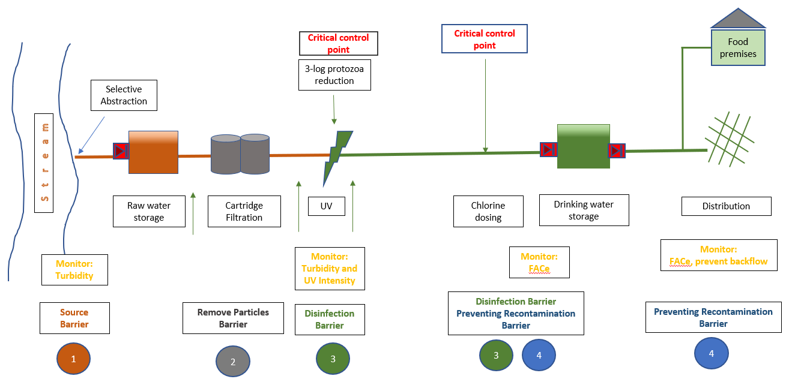

Example flow chart for ground water
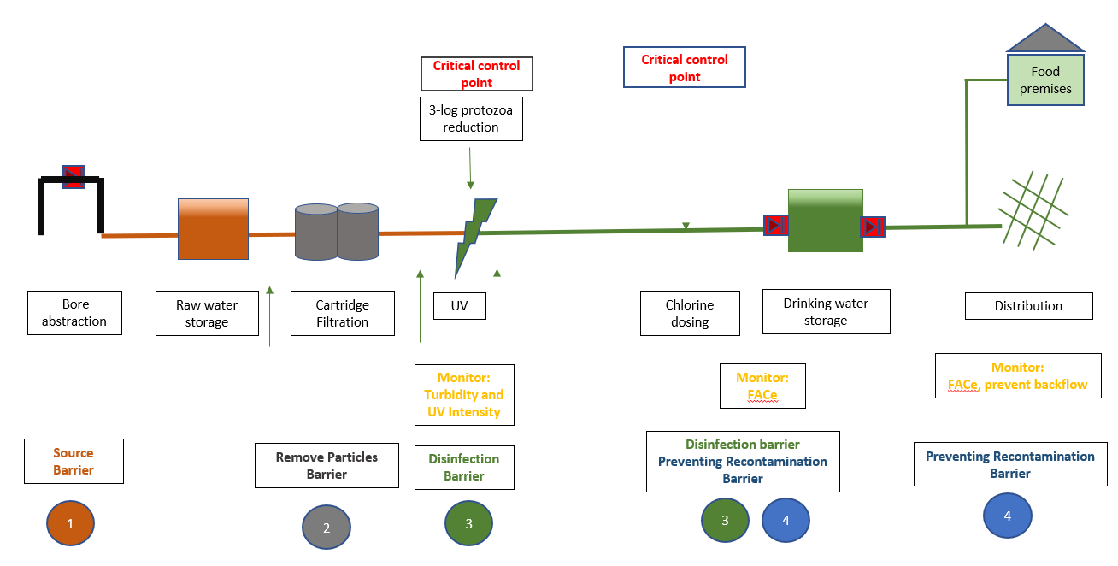

Example flow chart for water from existing supplier

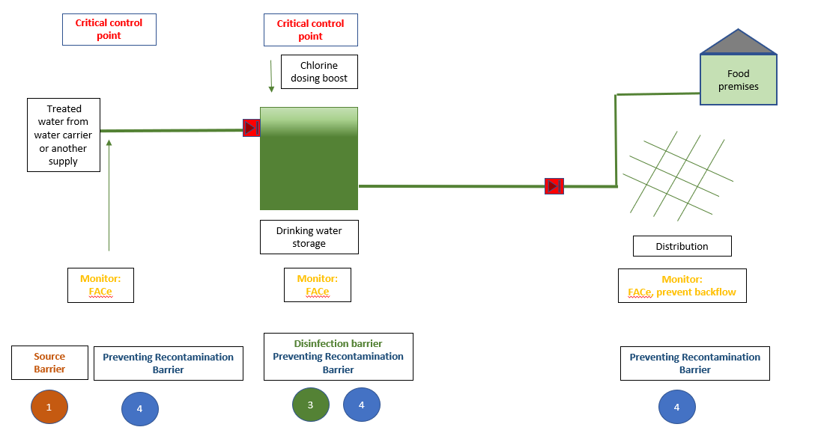

Appendix 2: Log reduction requirements for protozoa

The default log reduction requirements for protozoa are as follows:
Surface water sources require a minimum 4 log protozoa reduction
Ground water sources (bores/springs) require minimum 3 log protozoa reduction
Organisers seeking to implement lower log reduction values must provide additional evidence to demonstrate that the protozoa risk can be adequately controlled with the proposed treatment.

Appendix 3: Minimum analysis requirements for source water

Source Water Monitoring Determinands for Surface Water and Ground Water
Contaminant Group | Determinands
Bacterial | E. coli and total coliforms.
Physico-chemical | arsenic, boron, calcium, magnesium, nitrate potassium, bromide, iron, manganese, total organic carbon.

Source Water Monitoring Determinands for Roof Water
Contaminant Group | Determinands
Bacterial | E. coli and total coliforms.
Chemical | cadmium, copper, zinc, lead, benzo [a] pyrene (In winter – June, July or August).

Appendix 4: Critical Control Point Features and Decision Tree

What is a Critical Control Point (CCP)?
A CCP is a point in a temporary drinking water supply which is critical in the control of a hazard or hazards (contaminants). Identifying these points allows the development and implementation of monitoring procedures to ensure that these important points in the temporary supply are always operating effectively (controlled) and to identify any problems quickly. This allows action to be taken to ensure that control is maintained or, if control has been lost, to prevent harm to consumers. A point in a supply can be classed as a CCP if it has all the following attributes:
- the treatment step can be controlled
- the treatment step is designed to remove a hazard or reduce it to an acceptable level
- at least one operational parameter that can be monitored to provide a check on the performance of the treatment step
- at least one operational parameter that can be sampled, or read, frequently enough that suppliers can make a timely response to prevent harm to consumers in the event of loss of control at that CCP (monitoring should be continuous)
- performance limits can be set to show when optimum control is lost, and corrective action needed
- corrective actions can be defined so that in the event of target limits not being met the operator knows how to respond to the situation
- critical limits can be defined on the operational parameter(s) that if exceeded, (e.g., because corrective actions have failed to regain control) indicate that drinking water may be unsafe signal the need for a response.
Critical Control Point Decision Tree

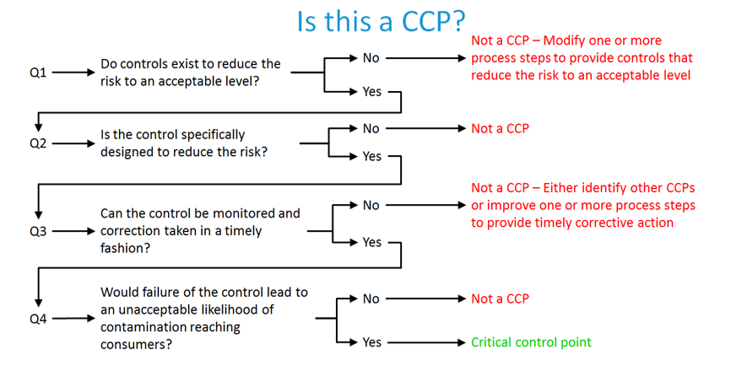

Appendix 5:

Example Critical Control Point Summary Sheet
This example covers primary disinfection by free chlorination with manual sampling and dose adjustment. It shows the sort of information that might be included. Process objectives
To inactivate bacterial, viral and most protozoan pathogens that may be present before dosing.
Provide protection from pathogens after treatment eg in the distribution. System
Operational day-to-day monitoring of chlorine and pH:
What | Free available chlorine (FAC) concentration in mg/L. pH in pH units
When | Daily 7 days per week
Where | The Disinfection Sample Point(s) are located……….
How | Hand-held Pocket Colorimeter with vendor-supplied reagents
Who | Operator
Records | Log book

Process performance criteria at the monitoring point: |  | Action required
Target Range: | FAC: 0.5 to 1.5 mg/L  pH: 7.0 to 8.0 | No action required. (The supplier knows that this will provide suitable FAC and pH levels throughout the reticulation).
Action Limits: | FAC:  < 0.2 – 0.5 mg/L  > 1.5 - 5mg/L pH: 8.0 – 9.0 | Duty Operator to respond by adjusting dosing and monitor closely until within targets Duty Operator to notify Duty Supervisor. (Readings in this level show that levels are drifting. This is the opportunity for the supplier to correct the problem before there is a transgression or incident)
Critical Limits: | FAC:  < 0.2 mg/L  > 5 mg/L  pH: > 9.0 (> 15 m) | Duty Operator to notify Duty Supervisor  Duty Supervisor to trigger appropriate response e.g. Inadequate chlorination protocol/ chlorine exceedance
The process performance criteria should link with the monitoring section of your plan.

Supporting programmes
Before productions starts:
Monitoring equipment must be checked and calibrated.
Currency of reagents must be checked, and any outdated reagents discarded.
Supplier must ensure that the people responsible for monitoring checks are trained and competent to assess free available chlorine levels in drinking water.
Ensure that chlorine used in for treatment is suitable for drinking water and has sourced from a reputable supplier.
Cross-check FAC and pH by independent laboratory.

Appendix 6:

Blank Critical Control Point Summary Sheet

Critical Control Points Summary for…

Process objectives

Operational day-to-day monitoring of ……………………………………:
What
When
Where
How
Who
Records

Process performance criteria at the monitoring point: |  | Action required
Target: |  | No action required.
Action Limits:
Critical Limits:

Supporting programmes

